Section A

- Choose which of these is an alcohol.
Tick ( ) one box.
- Ethane | 
- Ethene
- Ethanol

- Choose the function groups of the alcohols.
Tick ( ) one box.
- Hydroxyl group
- Hydroxide group
- Hydrogen group

- Complete the structural formula for propanol:

C C C

- The alcohols are a large family of compounds.
Determine the chemical formula of an alcohol with:
- 6 carbons

_______________________________________

- 8 carbons

_______________________________________

- 10 carbons

_______________________________________

Section B

- Methanol is an alcohol.
- Complete the dot and cross diagram to show the bonding in methanol.

- Give a use for methanol.

__________________________________________________________________________________________
__________________________________________________________________________________________

- Complete the word equation to show the complete combustion of methanol.

Methanol + oxygen ________________ + ________________

- Compare the products that would be produced through complete and incomplete combustion of methanol.

__________________________________________________________________________________________
__________________________________________________________________________________________
__________________________________________________________________________________________
__________________________________________________________________________________________

- Predict the products of the following reactions.

- Ethanol + sodium

- Propanol + sodium

- Butanol + sodium

- This question is for higher tier students.
Ethanol burns completely in air according to the following equation:

C₂H₅OH + 3 O₂ 2 CO₂ + 3 H₂O

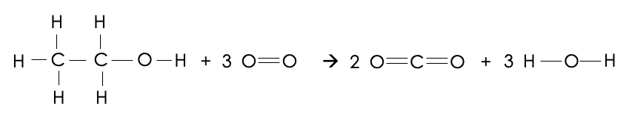
This reaction can be represented with structural formulae:

- Use the bond energies given in the table to calculate the overall energy change of this reaction.

Bond | Bond energy (kJ/mol)
C-C | 347
C-H | 413
C-O | 358
C=O | 799
O-H | 467
O=O | 495

__________________________________________________________________________________________
__________________________________________________________________________________________
__________________________________________________________________________________________
__________________________________________________________________________________________
__________________________________________________________________________________________
__________________________________________________________________________________________
__________________________________________________________________________________________
__________________________________________________________________________________________

- Use your answer to explain whether this reaction is exothermic or endothermic.

__________________________________________________________________________________________
__________________________________________________________________________________________
__________________________________________________________________________________________
__________________________________________________________________________________________

Section C

- Ethanol is an alcohol.
- State the chemical formula of ethanol.
- Draw the structural formula of ethanol.
- One use of ethanol is in alcoholic drinks. Give another use of ethanol.
- Describe some of the short term effects of alcohol on the body.
- Describe a simple experiment that could be used to estimate a person’s reaction time.
- Drinking alcohol affects the stopping distance of a car. Does this affect the thinking distance or the braking distance?
- Calculate the stopping distance of a car travelling at 10 m/s with a deceleration of 2.5 m/s². The diver’s reaction time is 0.4 seconds.

